Nginx Proxy Manager
(Add Proxy entry in NPM)
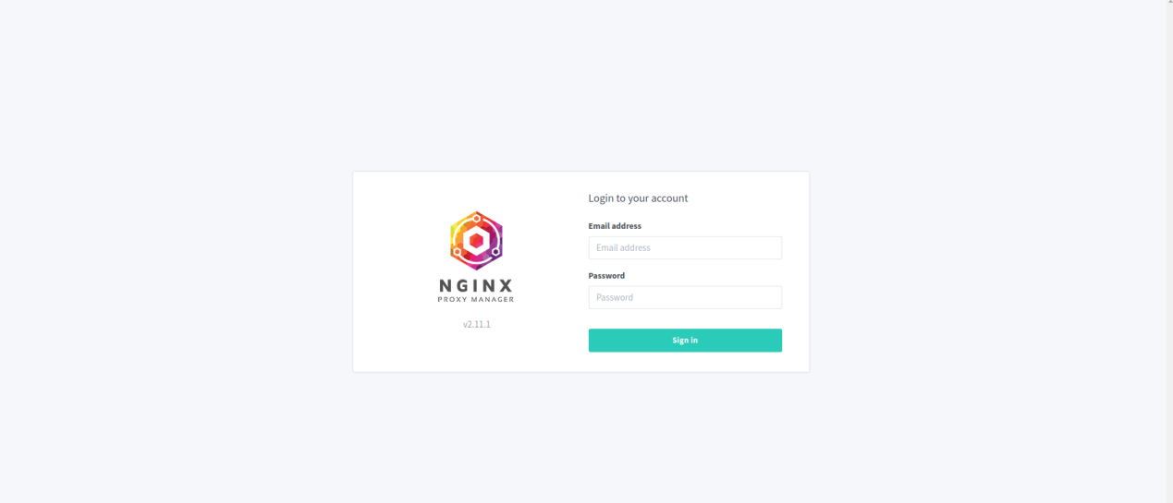

Note:
Banani Proxy Public IP: 202.53.174.254
DhakaColo Proxy Public IP: 103.204.80.121

1. Login to the web portal with your credentials using the urls http://192.168.20.253:81/ or http://192.168.11.253:81.

2. Go to ‘Proxy Hosts’ from ‘Hosts’ menu.
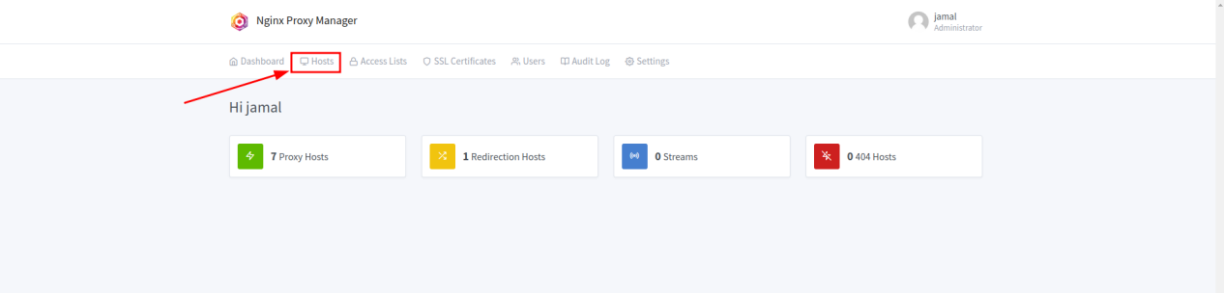

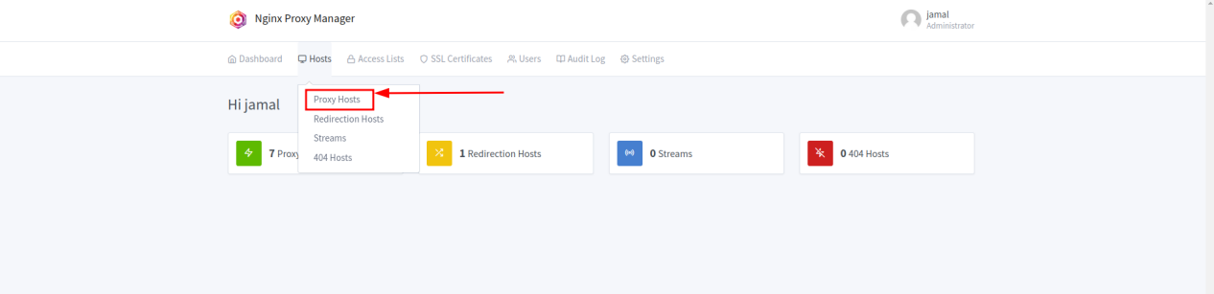

2. Click on ‘Add Proxy Hosts’ option.
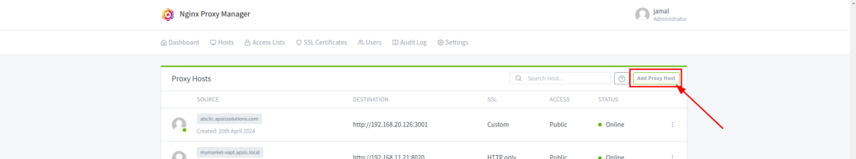

3. From ‘Details’, ‘SSL’ and ‘Advaned’ tabs, fill up the required information.
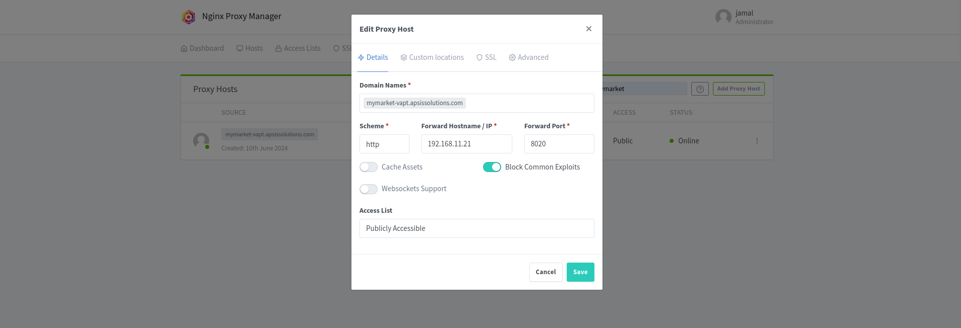

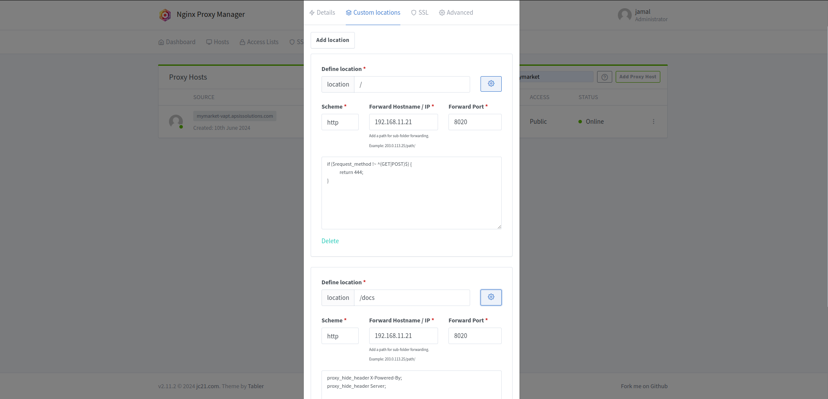

if ($request_method !~ ^(GET|POST)$) {
return 444;
}

proxy_hide_header X-Powered-By;
proxy_hide_header Server;

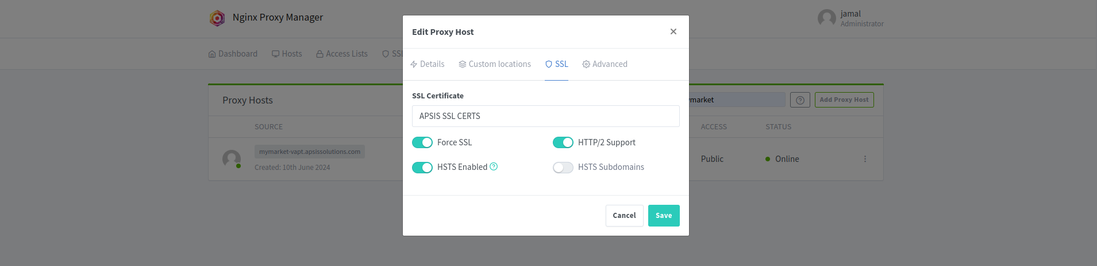

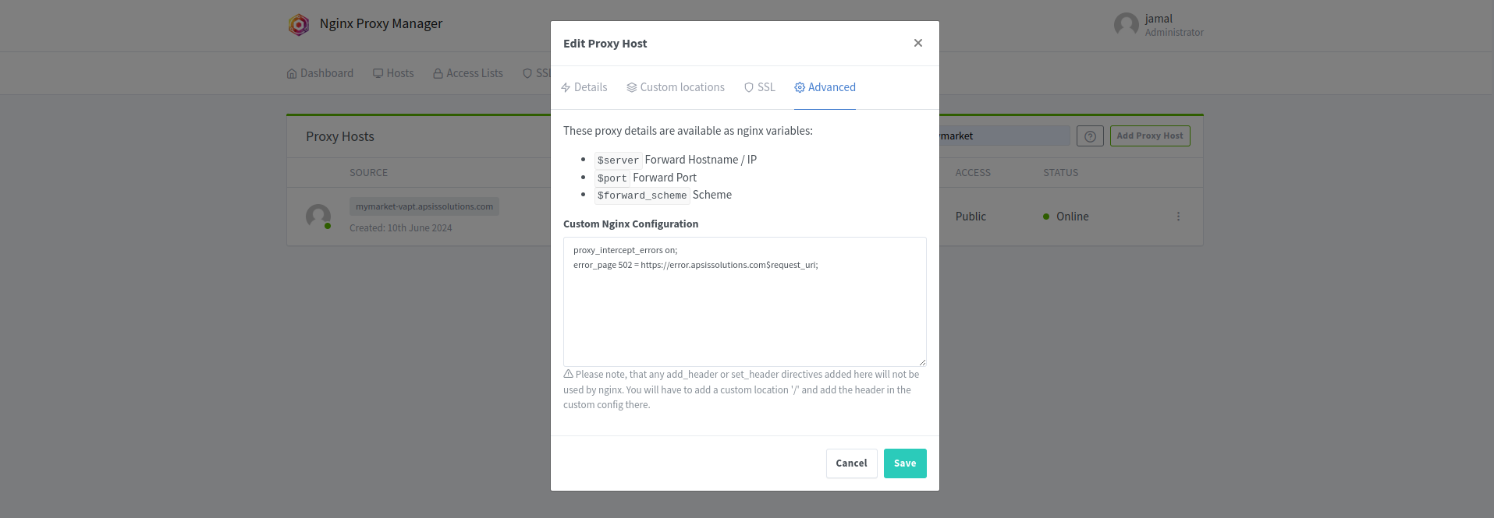

proxy_intercept_errors on;
error_page 502 = https://error.apsissolutions.com$request_uri;

4. After clicking ‘Save’ button the proxy will be workable after a few seconds.

